# freETarget

**Application Note: FreeETarget Traffic Lights**

**SUMMARY**

The FreeETarget Traffic Lights is an accessory that informs the shooter of a timing interval. Applications include

* Turn on and off a Rapid Fire event
* Used as a Tabata timer to train against over holding

**CIRCUIT DIAGRAM**

**page1image12895776**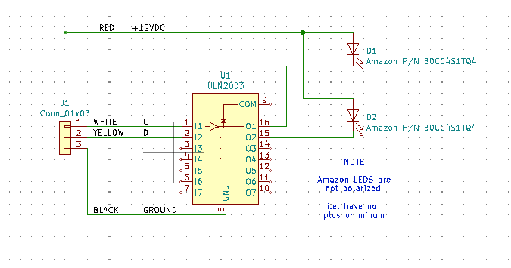

**Circuit Diagram The components are available from Amazon**

**CONNECTIONS**

The connector (J1) attaches to the MultiFunction connector (J1 on the circuit board) so that C, D, and GND line up with pins 4,5, and 6.

The loose RED wire attaches to the +12 supply

**MFS SETTINGS**

The Traffic Lights requires the following configuration to be applied to the Multi Function Switches

{"MFS_HOLD_C":18, "MFS_HOLD_D":20**, "MFS_SELECT_CD":22}**

**TESTING**

Once configured with the settings above, the Traffic Light indicators will cycle

* RED
* GREEN
* OFF

When powering up the board.  
The lights will go off unless used in Rapid Fire or Tabata